EXP-11
Link Jira with Confluence Aim To integrate Jira with Confluence for project tracking.
Procedure
1. Create a jira project and choose scrum template.
2. Enter a space name as Library Management System.
3. Go to backlog and create 5 tasks in sprint.
4. Start the sprint then, tasks will be shown.
5. In side bar choose more option & choose confluence .
6. Then the confluence page appears then, Create page in confluence.
7. Then give any title. In the blank space type ‘/jira’.
8. Click on jira legacy type the prompt ‘project=key order by status ASC’.
9. Click enter and insert the task. 10. Take a screenshot.
Output
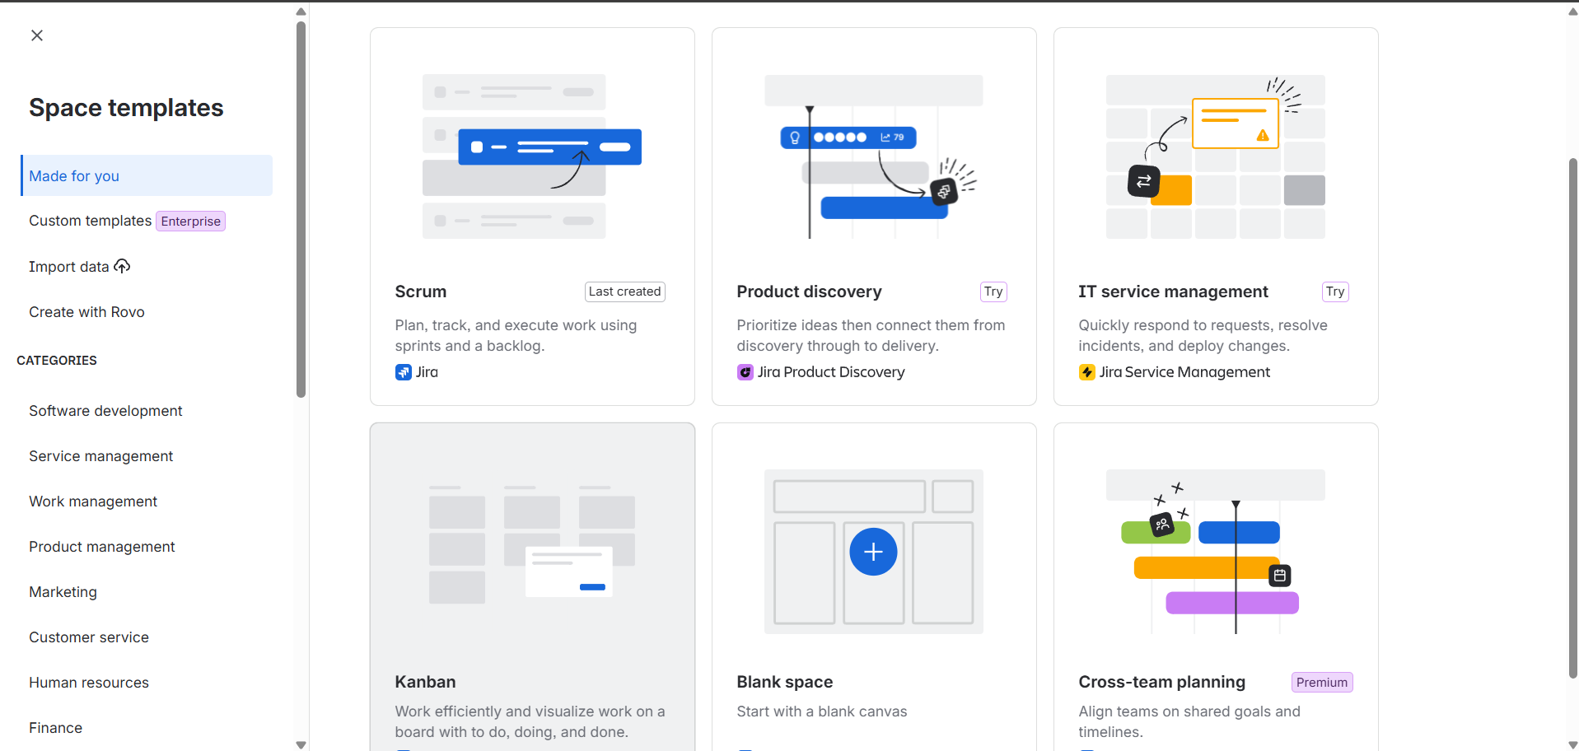
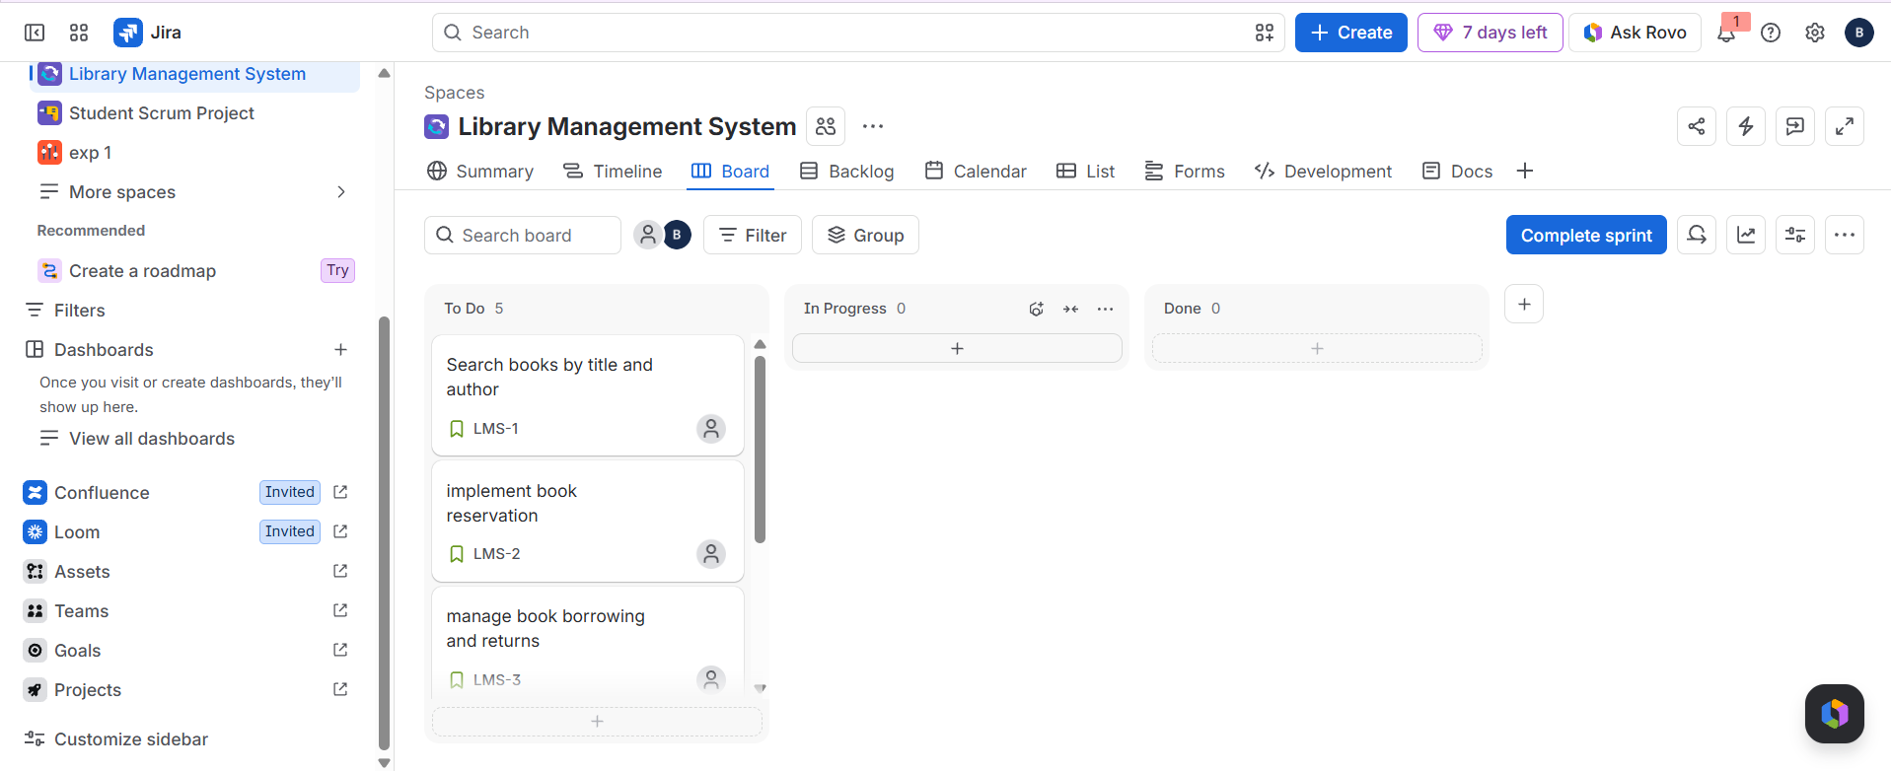
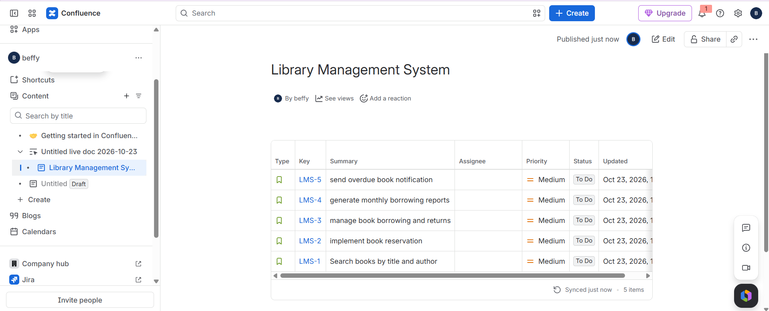
Result:
Thus, The Scrum sprint executed successfully and sprint board tracked progress.

